Palindrome User Manual

Kyle Elliott

https://github.com/kelli2bpt/NetworkingProject.git

## Installation and usage

*Note: The environment used for this program is Ubuntu 18.10 using the GCC compiler*

1. Install GCC using this command

***Sudo apt-get install gcc***

1. Wait for installation to finish
2. Compile the palindrome.c file

***Gcc -o palindrome palindrome.c***

1. Compile the palindrome server and client files using the command “***gcc -o pClient palindromeClient.c; gcc -o pServer palindromeServer.c”***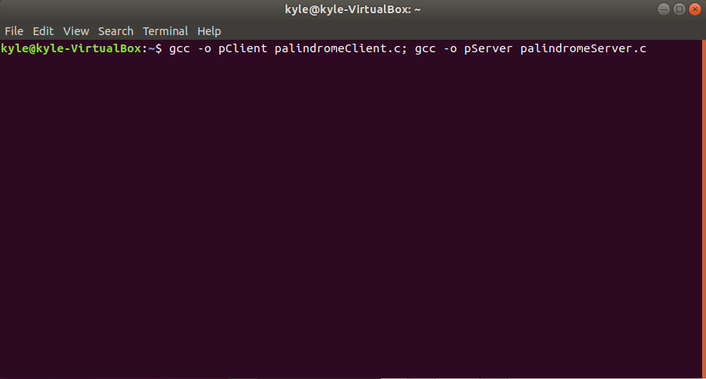
2. Run the server using the command ***“./pServer 4040”***

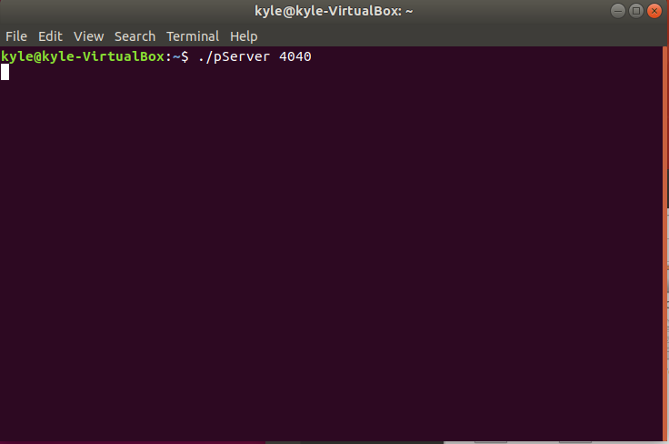

1. Run the client using the command ***“./pClient 127.0.0.1 4040”*** 127.0.0.1 being replaced with the IP address of your choice, and replacing 4040 with the port of your choice

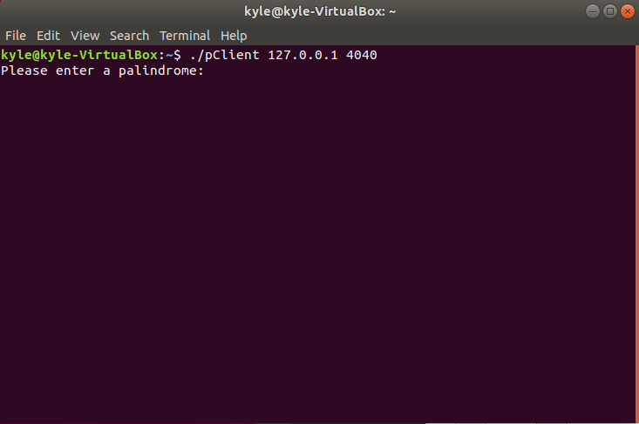

1. Enter a palindrome and press enter for results

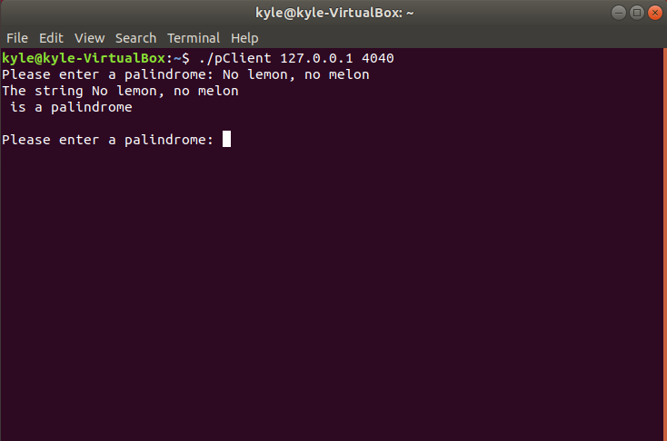

1. The file can also be run locally using the palindrome.c file instead
2. Run terminal and use the command ./palindrome
3. Enter a palindrome and hit enter for results

## Testing

1. Testing the connection between client and server inside one VM using Ubuntu 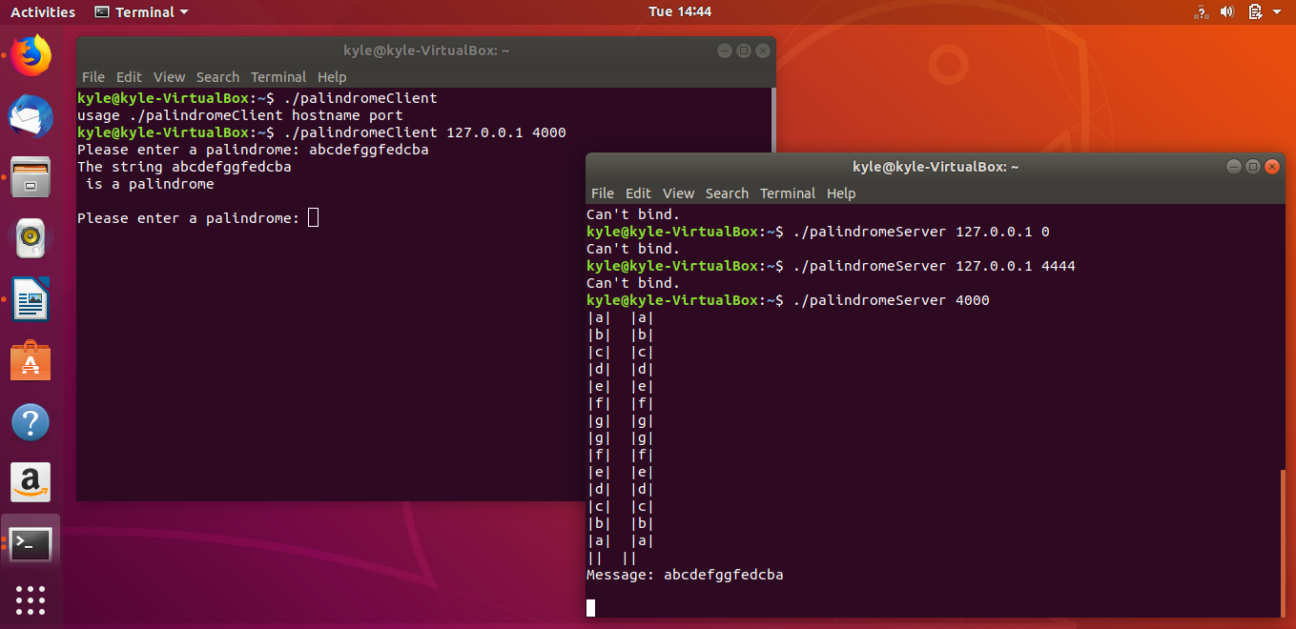
2. Testing the examples given by the project requirements

